Health and safety

Interactive Application Proposal for the Manukau Institute of Technology

**Contents**

**1.** **Introduction** 4

**1.1 Health and Safety** 4

**1.2 Solution and Research Question** 4

**1.3 Measurable Organisational Value (MOV)** 4

**1.4 Software Methodology** 4

**2.** **Existing System and Other Applications** 5

**2.1 Current Health and Safety System** 5

**2.2 Existing Applications** 6

**2.2.1 PeopleSafe** 6

**2.2.2** **Learn Workplace Safety** 7

**2.2.3** **Mobile Safety** 8

**2.2.4** **Safety Representative Training** 9

**2.2.5** **Victoria University of Wellington Health and Safety Website** 10

**2.3 Existing Applications Benefits and Faults** 11

**3.** **Software and Research Methodology** 12

**3.1 Software Methodology** 12

**3.2** **Research Methodology** 12

**3.3** **The Product and the Added Values** 13

**4.** **Resources** 14

**4.1 Android Studio** 14

**4.2 Office 365** 15

**4.3 Visual Studio** 15

**5.** **Project Risks** 16

**5.1 Time Constraints** 16

**5.2** **Lack of Communication** 16

**5.3** **Hardware Failure** 16

**5.4 Lack of Experience** 16

**6.** **Planning Required** 17

**6.1** **Responsibilities** 17

**7.** **Conclusion** 18

**8.** **References** 19

**9.** **Appendixes** 21

**9.1 Appendix A.1** 21

**9.2 Appendix A.2** 22

**9.3** **Appendix A.3** 22

**10. Work Breakdown Structure** 23

**11.** **Wireframes** 25

**11.1.** **Home Screen Activity** 25

**11.2.** **Documentation Activity** 26

**11.3.** **Emergency Information Activity** 27

**11.4.** **Quiz Activity** 28

**11.5.** **Video Activity** 29

**11.6.** **Landing Page** 30

**12.** **Graphical User Interface Screens** 31

**12.1.** **Homepage Activity** 31

**12.2.** **Emergency Info Activity** 32

**12.3.** **Video Activity** 33

**12.4.** **Quiz Activity** 34

**12.5.** **Quiz Result Activity** 35

**13.** **Navigation Diagram** 36

**14.** **Use Case Diagrams** 37

**14.1.** **Administrator Landing Page Use Case** 37

**14.2.** **Administrator Android Application Use Case** 37

**14.3.** **Student Landing Page Use Case** 38

**14.4.** **Student Android Application Use Case** 38

**15.** **Implementation Phase** 39

**16.** **Error Handling** 40

**17.** **Improvements/Future Considerations** 41

**17.1.** **Design** 41

**17.2.** **Relevant Documentation** 41

**17.3.** **Databases** 41

**18.** **Team Meetings** 42

**18.1 Meeting 1** 42

**18.2 Meeting 2** 43

**18.3 Meeting 3** 44

**18.4 Meeting 4** 45

**18.5 Meeting 5** 46

**18.6 Meeting 6** 47

**18.7 Meeting 7** 48

**19.** **Questionnaire Design** 49

**20. References** 53

# **Introduction**

## **1.1 Health and Safety**

Health and safety refers to guidelines and processes that are implemented within a place of work or communal environment to avoid accident or injury (Health and Safety, n.d.). In New Zealand, companies and individuals must adhere to health and safety procedures by law, as set out in The Health and Safety at Work Act 2015, which makes everyone responsible for their own and others safety (Health and Safety at Work Act 2015, 2017). Due to everybody being responsible for health and safety, this document will propose why it is necessary for an interactive application around health and safety be developed and offered to students attending the Manukau Institute of Technology, to help raise student awareness of their responsibilities at their place of study.

## **1.2 Solution and Research Question**

This project involves improving health and safety procedures at the Manukau Institute of Technology by making it more interactive via a mobile application which will make health and safety awareness more accessible to students. A health and safety video and website are other alternatives that may be implemented if time permits. This application that is being proposed is to answer a very important question; Can a mobile application improve awareness of health and safety for students at the Manukau Institute of Technology?

## **1.3 Measurable Organisational Value (MOV)**

The Measurable Organisational Value (MOV) of this project is targeted towards the social aspect of the Manukau Institute of Technology. This is because students are some of the most important people for the future of New Zealand, as the skills they are going to learn whilst studying, will one day have a positive impact and influence on the future of the country. By giving students the tools to keep themselves and others safe in their place of study, the Manukau Institute of Technology should see a minimum of 50% reduction of student incidents over all three of their current campuses. The health and safety knowledge that they are being given will enable them to identify hazards and suggest ways of minimizing or eliminating these hazards for the safety of everyone. This is especially important for international students, as the health and safety standards in their own country may be vastly different to the standards within New Zealand. Ultimately, we are trying to raise student awareness about health and safety, but because this is not measurable, and we have time constraints to get this project finished, we will not be focussing on student awareness, but rather, achieving the reduction of student incidents at the Manukau Institute of Technology.

## **1.4 Software Methodology**

Agile and Extreme Programming (XP) are the chosen software methodologies that are going to be used for the develop of the application and website. This is due to requirements that could potentially change during the development lifecycle, the size of the software development team (two people), the short time schedule for development, the necessity for simplicity, and the feedback that the team will constantly be receiving throughout the projects lifetime (Extreme Programming, n.d.; Wells, n.d.).

# **Existing System and Other Applications**

## **2.1 Current Health and Safety System**

The Manukau Institute of Technology currently have a health and safety guide that only staff can view on the employee intranet. When a new staff member starts at the polytechnic, they are required to view these documents and fill out a questionnaire related to this guide, this questionnaire then gets filed under that new employee’s paperwork. Additionally, there is an incident reporting tool available for staff and students on the polytechnics website.

We have had many difficulties obtaining the health and safety documentation that is available for staff at the Manukau Institute of Technology. We have emailed both Chris Mayhew and Fadi Fayez three times over the last three weeks, to organise a meeting with a health and safety officer. Together, they have sent several emails to the health and safety department at the Otara campus to arrange a meeting but have not received any replies to these emails. We have also scoured <http://www.manukau.ac.nz> to find any documentation or information available to the public but unfortunately, there is only an incident reporting tool available and no relevant documentation whatsoever.

There are several significant problems with this current system.

1. There is no access for students or visitors to view these health and safety guidelines.
2. When a student first starts at the Manukau Institute of Technology, they do not receive a health and safety briefing or instructions on what to do in the event of a fire or emergency.
3. Once the new employee has had their questionnaire filed, there are no yearly follow up meetings identifying new hazards or changes to the guidelines.
4. Students are not instructed on where the incident reporting tool is located, what it entails, or how to use it.
5. Currently, staff are required to read several detailed pages of documentation which is time consuming and can easily be forgotten.
6. Students are not required to fill out a health and safety questionnaire when first starting at the Manukau Institute of Technology so have no idea about hazards, risks, procedures, and responsibilities.

## **2.2 Existing Applications**

There are a large variety of existing mobile applications and websites that feature health and safety and explain its importance. All these applications have their own strengths and weaknesses and encompass health and safety for a large variety of jobs and workplaces. Five of these applications have been carefully selected that relate closely to what the proposed application needed at the Manukau Institute of Technology will feature.

### **2.2.1 PeopleSafe**

The first application that has been chosen for review is called PeopleSafe. It is a monthly subscription service that gives a company access to cloud software and a mobile application (Want Common Sense Health and Safety in Your Business?, 2016). Some of its important features include being able to communicate and have conversations about health and safety with everyone that has the software or mobile application installed, guidelines on setting up and managing the risks in your workplace, access to emergency plans and procedures, fast recording of safety events and new risks, gives every individual the knowledge they need to make a difference, simple navigation, sleek layout, and accessibility from any machine; computer, laptop, smartphone, etc (Clever Online Software, 2016).

Although this software and application have many positive traits, it is not without its downfalls as well. The navigation menu is huge and would easily confuse students about where critical information around health and safety is located, especially for international students. PeopleSafe do not include a health and safety manual or any documentation about what health and safety is, which is an crucial aspect students need to know and understand. On top of this, both the application and the cloud software do not give the user any place to upload documentation or videos that may be important to that company’s place of work.

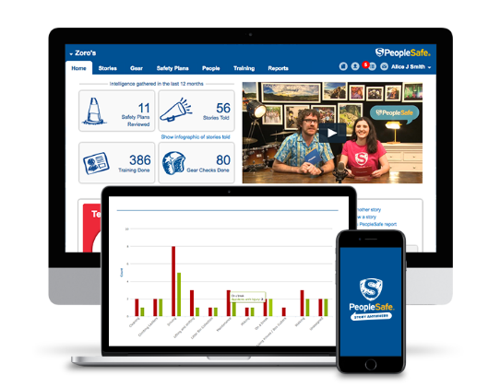

Fig. 1. (Want Common Sense Health and Safety in Your Business?, 2016)

### **Learn Workplace Safety**

Learn Workplace Safety is a free application offered on the Google Play store which was developed by one man; G. Hoang. It features an in-depth guide around what health and safety is, what hazards and risks are and how to manage them, responsibilities as an individual, and how to train individuals on workplace safety (Hoang, 2018). The developer has included advertisements within the application to be able to offer it to consumers as a free download. Also, a simple design and easy navigation are what makes this application so attractive.

The main aspect of having health and safety documentation available to students within a free application is ultimately what this project requires. However, there are a few of essential features that this application is lacking. After reading all the documentation, a questionnaire should be available to be filled out to make sure the user has understood what they have just read. A video or small game should be offered to make the application more interesting, as many students would get very bored reading pages upon pages of documentation. Lastly, the ability to be able to talk to other students via the application would be a huge improvement. Being able to share thoughts or talk about new risks that have been identified with everyone using the application, would certainly make a workplace a lot safer.

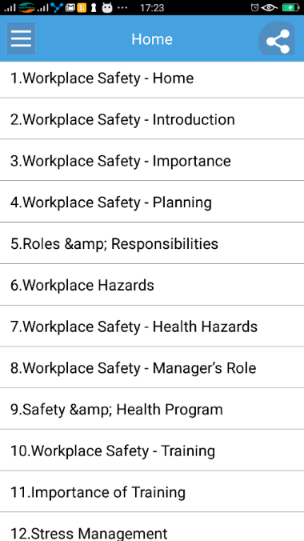

Fig. 2. (Hoang, 2018)

### **Mobile Safety**

Red River College in Manitoba, America, employ an application called Mobile Safety for their staff, students and faculty. It features some useful tools like emergency planning and info, safety tips, a personal safety toolbox, important contact information, and Safewalk; a tool that allows an individual to request a security escort if they are on the campus after normal teaching hours (Clarke, 2017). This application has student safety as one of their top priorities and does an excellent job of this, through their easy and understandable navigation menu.

Although this app is excellent in providing safety solutions for students, it is let-down in its lack of documentation around health and safety, e.g. procedures, laws, responsibilities, hazards, and risks. It provides a useful tool for students to identify hazards each day but does not actually explain what a hazard is or how to eliminate, isolate or minimize each hazard (Tattersfield, 2016). This application also does not provide any videos or a questionnaire for students to fill out to make sure each student understands what health and safety is.

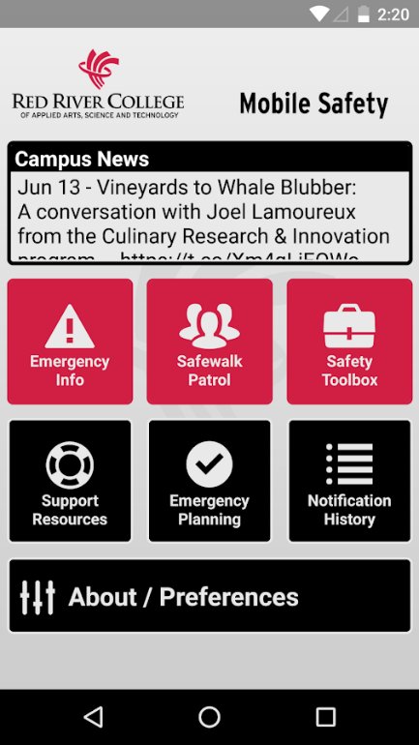

Fig. 3. (Clarke, 2017)

### **Safety Representative Training**

This application is quite a lot different to all the others that have been reviewed thus far. It provides a platform for students to become a health and safety representative. This is done by studying documentation within the application and completing an examination when the student feels capable in their knowledge of health and safety. There is no pressure on students to complete this examination as it can be done in their own time so will not interfere with their studies. When complete and the student has achieved a pass mark in the examination, they then receive a certificate that verifies them as a health and safety representative (Botes, 2017). Although this does not totally relate to the application that is being proposed, enabling students to become health and safety representatives would be a positive move, as these representatives would not only make the Manukau Institute of Technology safer, but they would be able to help promote the health and safety application to new students.

The only major downfall with this application is, although it is offered in several languages, including English, every country has their own unique health and safety guidelines and laws, and because this was made in South Africa, the guidelines featured in the application may not apply to New Zealand. Further research into the application would be required before pursuing this avenue any further.

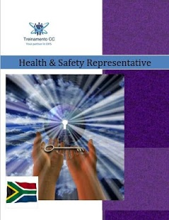

Fig. 4. (Botes, 2017)

### **Victoria University of Wellington Health and Safety Website**

Victoria University is a prominent university located in Wellington, New Zealand. It has a dedicated health and safety section on their main website which is available to browse for staff, students and the public. It offers a training programme, safety video, hazarding reporting form, emergency contacts, and other health and safety related tools. On top of this, the website features personalised health and safety for students, staff, or contractors, something that is very important as health and safety relates differently to each of these groups of people (Health and Safety, 2017). Just by having a quick browse of the websites health and safety page, it is plain to see that Victoria take health and safety very seriously.

The merits of Victoria University’s website far outweigh the negatives, of which, there is only one that needs to be mentioned. The layout of the health and safety page is extremely cluttered. All information that relates to a particular topic, e.g. events, community, associated links, etc. are made into a collection and have their own containers for that content, separating each topic appropriately (Health and Safety, 2017). This is an effective way to organise information, however, each container is sized differently and placed on the webpage in different positions which causes the webpage to seem very cluttered and unattractive.

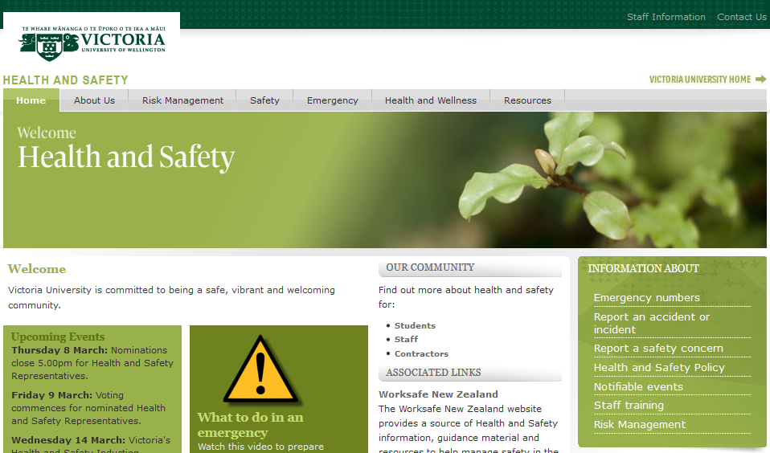

Fig. 5. (Health and Safety, 2017)

## **2.3 Existing Applications Benefits and Faults**

All of the applications discussed above have features and functionalities that we would like to use in our application and features that may be of no benefit as well.

The first application discussed; PeopleSafe, has two major features we would benefit from by including in our application. The first is the ability to able to communicate with any or all users of the application in order to have meaningful and organised discussions about health and safety. This would act like a Facebook Messenger or WhatsApp service and would also allow administrators to notify all users of upcoming changes to the app or the health and safety policy. The second is the cloud service that PeopleSafe offer. Our scope currently allows for an Android application and website, however, if more time was permitted, offering a cloud service via the web, that could be downloaded onto a desktop, laptop or tablet computer would be largely beneficial to the entire Manukau Institute of Technology community; not just students. Although both of these features would be extremely valuable to our project, with the time restriction we have, neither of these features are going to be included in our scope, however may be considered for future upgrades to the system we are proposing.

The three applications that we covered; Learn Workplace Safety, Mobile Safety and Safety Representative Training all have their own strengths and weaknesses. All three have a simple and easy to navigate Graphical User Interface (GUI) which we consider is essential to include in our proposed application and website, as these functionalities can be the difference between success or failure for many different types of software. Secondly, all three applications store a large amount of information and documentation, e.g. a health and safety guide, which is another feature that our application absolutely requires. The third and final feature of all three of these applications that we will definitely include in our proposed application is publishing the application on the Google Play Store as a free download. The application is trying to raise student awareness about health and safety and not about turning a profit so advertisements, like the ones in the Learn Workplace Safety application, is a feature that is unnecessary for this project and will not be included in our scope.

The Victoria University’s health and safety section of their website is brilliant. It has many features that will be useful to include in our project and hardly any downfalls. The simple navigation, separation and collection of valuable information, safety video, hyperlinks to other useful websites, and vibrant colour of the website are all features and functionalities that we would like to include in our project. Unfortunately, due to time constraints, we will not be able to include the several useful tools, training and events, or emergency information features that this website has, however, would definitely push for these features in later updates.

# **Software and Research Methodology**

## **3.1 Software Methodology**

The software methodology used in the project are a mix of Agile and Extreme Programming principles. Agile imposes working collaboratively, flexibly and incrementally, and does not impose an individual methodology or framework. There are a number of popular frameworks that Agile adopts and the most popular ones are Kanban, Scrum and Extreme Programming. A lot of Agile teams adopt different elements of each framework when working in an Agile environment, but we will be focusing on the Extreme Programming framework within Agile (Agile Frameworks – Scrum, Kanban and Extreme Programming, 2017).

Extreme Programming is a framework that ensures small teams work collaboratively in brief development cycles and are adaptable to change. It utilizes user stories and intermittent small releases (Agile Frameworks – Scrum, Kanban and Extreme Programming, 2017).

Extreme Programming have twelve core practices and we will be implementing a number of them throughout the lifecycle of our project (Agile Frameworks – Scrum, Kanban and Extreme Programming, 2017). The practices include:

* Test Driven Development
* Pair Programming
* Simple Design
* Planning Game (frequent release and iteration planning)
* Small Releases (with design improvements or working functionally)
* Collective Code Ownership
* Coding Standards

## **Research Methodology**

Qualitative research methodology is going to be used in this project, by analysing the existing health and safety system at the Manukau Institute of Technology and other health and safety applications on the internet. Qualitative research is multi-method in focus, involving an interpretive, naturalistic approach to its subject matter (McLeod, 2008). Seeing that we can’t place qualitative data into numbers or a graph, we went through the existing system at MIT and chosen applications on the internet, taking note of strengths and weaknesses of each application. This resulted in a list of functionalities that we could implement in our application to insure it is effective in raising awareness of health and safety at MIT.

## **The Product and the Added Values**

There are three aspects to our software system; an application, a website and a health and safety video. The website is a landing page which give students a quick explanation about the application and a link to download the application as well. The application is going to include health and safety documentation, the video which we are going to film at the Manukau Institute of Technology, a link to the student incident reporting tool, and a questionnaire about the information within the application. The health and safety documentation will include definitions, the Health and Safety at Work Act 2015, and roles and responsibilities. The video is going to be a few minutes long and will identify hazards at the Manukau Institute of Technology, emergency procedures and what to do when an incident occurs.

All three of these concepts is going to add value to student life at the Manukau Institute of Technology. Ultimately, we are aiming to reduce student incidents by identifying and mitigating hazards. We are achieving this by raising student awareness by making the health and safety regulations more interactive and accessible with our proposed products, thus fulfilling our Measurable Organisational Value (MOV) which is, giving students the tools to keep themselves and others safe in their place of study.

# **Resources**

## **4.1 Android Studio**

Android Studio’s Integrated Development Environment (IDE) is a valuable resource for developing native Android applications on Google’s Android Operating System. Android Studio has a large variety of features that are very useful for the full development lifecycle of an application (Meet Android Studio, n.d.). Some of the features include:

* Refactoring code and quick fixes.
* Lint tools to catch performance and version compatibility problems.
* A rich layout editor that allows users to drag-and-drop UI components, option to preview layouts on multiple screen configurations.
* Android Virtual Device to debug apps on different Android Operating Systems.

Java programming language will be the chosen language that will be used to code this application, which runs on Android studio.

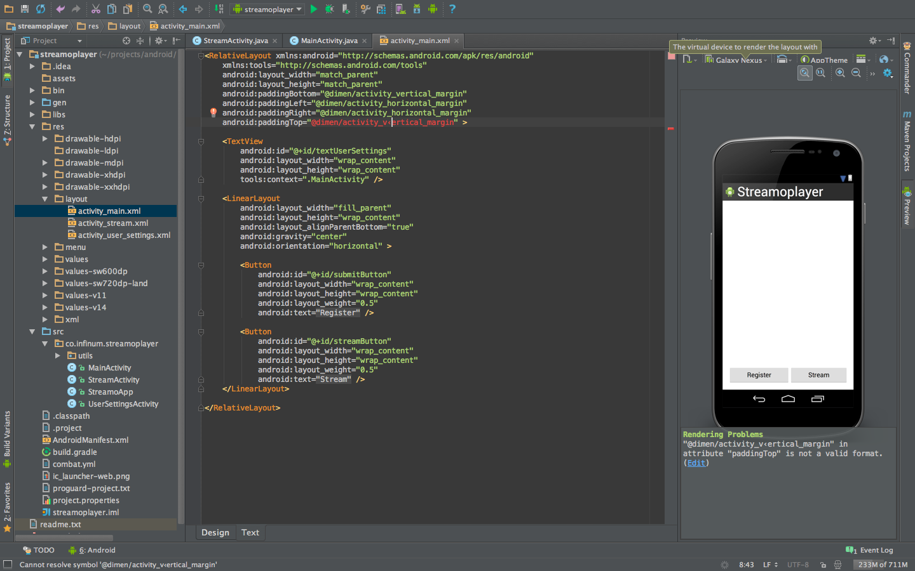

Fig. 6. (Plesac, 2013)

## **4.2 Office 365**

Over the whole process of this project we will be using Microsoft Office 365 many times to complete tasks such as, Word document for proposal, PowerPoint for presentation and email for communication between team members. 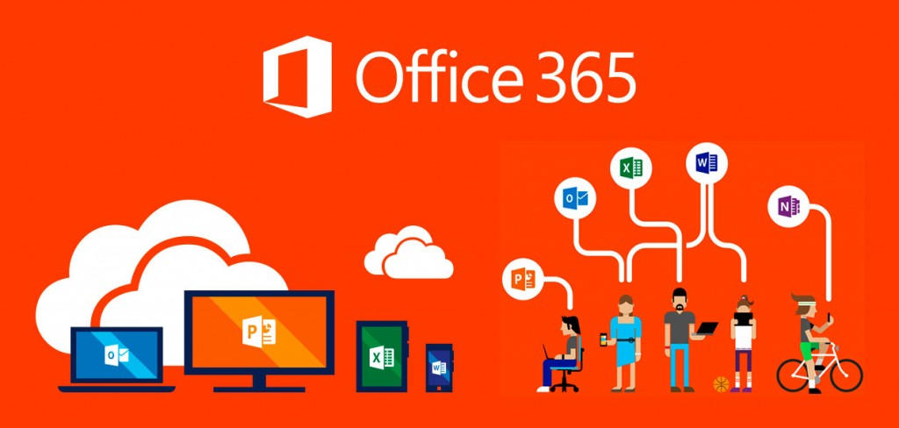

Fig. 7. (Microsoft 365 Education, n.d.)

## **4.3 Visual Studio**

Microsoft Visual Studio will be used as an Integrated Development Environment (IDE) to develop the landing page for our health and safety application. Coding languages used to develop the landing will be HTML for creating the structure of the webpage and CSS for styling the webpage.



Fig. 8. (Visual Studio IDE, n.d.)

# **Project Risks**

This project has several risks which will need to be managed appropriately to produce a quality product by the end of the project deadline.

## **5.1 Time Constraints**

The overall project has been given a total of eight weeks to complete every task set forth. For a project of this magnitude, eight weeks is not a lot of time, especially since this is the first time both Logan and I have undergone a project of this magnitude. To manage this risk, a weekly meeting between Logan and I is imperative to discuss what has been achieved and what has taken longer than expected. On top of that, a Gantt chart has been created to detail exactly what tasks need to be done and by what date. Both the meetings and Gantt chart are important for this project; however, unforeseen problems may arise that will affect our schedule and will need to be managed appropriately.

## **Lack of Communication**

Projects can fail all too often because of communication issues. Methods of communication, e.g. email, phone and face-to-face is one aspect of this risk as communication is interpreted differently between all three of these methods. The other aspect is people. Team members, lecturers, health and safety officers, and stakeholders all have different schedules. This means that if clarification on a part of the project is needed, relevant documentation is required, or just a general discussion is desired, it will generally not happen within a short time period and will need to be scheduled. To manage this risk, Logan and I will need to anticipate required meetings as best we can and organise them as soon as possible. Also, communicating face-to-face as often as we can is also necessary as this has always been the best form of communication.

## **Hardware Failure**

Unfortunately, computers are not perfect and can fail from time to time. A faulty hard drive, corrupt version of Windows, or even dropping and breaking our Android phone that we will use to test our application are some examples. If any of these things were to happen, they would undoubtedly affect our project and schedule. The best way that this risk can be managed is by making backups of our work after every session we spend working on the project.

## **5.4 Lack of Experience**

Logan and I are students that do not have great deal of experience coding, testing, designing or developing. What’s more, we have only had one class to learn Android Studio which is the software we are going to be using to develop our application. This means that both of us will inevitably run into problems whilst coding and will have to do a lot of reading and researching on how to fix these problems. Our maturity, willingness to learn and perseverance are all qualities which will need to be utilized to the fullest to manage this risk.

# **Planning Required**

As project leader, I (Chris Watson) have tried to divide the tasks up evenly so that both Logan and I do a fair amount of work to contribute to the overall project.

## **Responsibilities**

Chris Watson is the project leader and responsible for the following tasks:

1. Organising meetings with lecturer and health and safety officer.
2. Organising weekly minute meetings.
3. PowerPoint presentation for both presentations.
4. Delegating who is talking about what for presentations.
5. Research proposal except Software and Research Methodology and Resources sections.
6. Getting research proposal checked with lecturer and making changes as needed.
7. Gantt chart.
8. Assisting Logan when required with coding and testing.

Logan Shaw is the lead developer and responsible for the following tasks:

1. Software and Research Methodology and Resources sections of the research proposal.
2. Proofreading.
3. Choosing software to develop application and website.
4. Choosing research methodology to follow.
5. Coding and testing a large majority of the website and application but also getting Chris to assist when required.
6. Filling in weekly team meeting minutes form.

Both Chris and Logan are responsible for completing these tasks together:

1. Attending weekly team meetings.
2. Designing application and website.
3. Producing a video for the software.
4. Completing tasks within the scheduled timeframe.
5. Presentations.

# **Conclusion**

Overall, health and safety for students at the Manukau Institute of Technology is of paramount concern and by proposing these solutions, even if we only slightly improve student life, we believe that we will have achieved our goal. There are many risks that we may encounter along the way and that can have an effect on this project to cause it to ultimately end in failure, however, because health and safety is so important and Logan and I have a passion for learning and completing tough challenges, we have optimism that this new system will be delivered on time and to a high quality.

# **References**

*Agile Frameworks – Scrum, Kanban and Extreme Programming*. (2017, January 12). Retrieved from EPA Developers Guidance: https://developer.epa.gov/guide/templates-guides/agile/agile-frameworks/

Botes, J. (2017, April 11). *Safety Representative Training*. Retrieved from Google Play: https://play.google.com/store/apps/details?id=hsrepresentative.johann.com.healthandsafetyrepresentative

Botes, J (2017, April 11). Image. Safety Representative Training. Retrieved March 10, 2018 from: https://play.google.com/store/apps/details?id=hsrepresentative.johann.com.healthandsafetyrepresentative

Clarke, D. (2017, June 13). *Mobile Safety*. Retrieved from Google Play: https://play.google.com/store/apps/details?id=com.cutcom.apparmor.rrc

Clarke, D. (2017, June 13). Image. Mobile Safety. Retrieved March 2, 2018 from Botes, J (2017, April 11). Image. Safety Representative Training. Retrieved March 10, 2018 from: https://play.google.com/store/apps/details?id=hsrepresentative.johann.com.healthandsafetyrepresentative

*Clever Online Software*. (2016). Retrieved from PeopleSafe: https://www.peoplesafe.co.nz/cloud-based-safety-software/

Denzin, N. &. (1994, .(1994). Handbook of Qualitative Research. Thousand Oaks, CA, US: Sage Publications Inc.). *Handbook of Qualitative Research.* Retrieved from https://www.simplypsychology.org/qualitative-quantitative.html

*Extreme Programming*. (n.d.). Retrieved from Agile Alliance: https://www.agilealliance.org/glossary/xp/#q=~(filters~(postType~(~'post~'aa_book~'aa_event_session~'aa_experience_report~'aa_glossary~'aa_research_paper~'aa_video)~tags~(~'xp))~searchTerm~'~sort~false~sortDirection~'asc~page~1)

*Health and Safety*. (2017, May 9). Retrieved from Victoria University of Wellington: https://www.victoria.ac.nz/healthandsafety

*Health and Safety*. (2017, May 9). Image. Retrieved March 10 2018 from: https://www.victoria.ac.nz/healthandsafet

*Health and Safety at Work Act 2015*. (2017, September 4). Retrieved from Worksafe: https://worksafe.govt.nz/laws-and-regulations/acts/hswa/

*Health and Safety*. (n.d.). Retrieved from English Oxford Living Dictionaries: https://en.oxforddictionaries.com/definition/health_and_safety

Hoang, G. (2018, February 1). *Learn Workplace Safety*. Retrieved from Google Play: https://play.google.com/store/apps/details?id=com.appsgooder.workplacesafety

Hoang, G (2018, February 1). Image. Learn Workplace Safety. Retrieved March 2, 2018 from: https://play.google.com/store/apps/details?id=hsrepresentative.johann.com.healthandsafetyrepresentative

McLeod, S. (2008). *Qualitative vs. Quantitative*. Retrieved from Simply Psychology: https://www.simplypsychology.org/qualitative-quantitative.html

*Meet Android Studio*. (n.d.). Retrieved from Android Studio: https://developer.android.com/studio/intro/index.html

*Microsoft 365 Education*. (n.d.). Retrieved from Microsoft: https://www.microsoft.com/en-us/education/buy-license/microsoft365/default.aspx

Plesac, Ž. (2013, June 18). *Android Studio vs. Eclipse - 1 : 0*. Retrieved from Infinum: https://infinum.co/the-capsized-eight/android-studio-vs-eclipse-1-0

Tattersfield, R. (2016, July 19). *Health and Safety at Work (General Risk and Workplace Management) Regulations 2016*. Retrieved from Safely: http://www.safely.nz/newsroom/health-and-safety-at-work-general-risk-and-workplace-management-regulations-2016

*Visual Studio IDE*. (n.d.). Retrieved from Microsoft: https://www.visualstudio.com/vs/

*Want Common Sense Health and Safety in Your Business?* (2016). Retrieved from PeopleSafe: https://www.peoplesafe.co.nz/

Want Common Sense Health and Safety in Your Business? (2016). Image. Retrieved March 2, 2018 from: https://www.peoplesafe.co.nz/

Wells, D. (n.d.). *When should Extreme Programming be used?* Retrieved from Extreme Programming: http://www.extremeprogramming.org/when.html

# **Appendixes**

## **9.1 Appendix A.1**

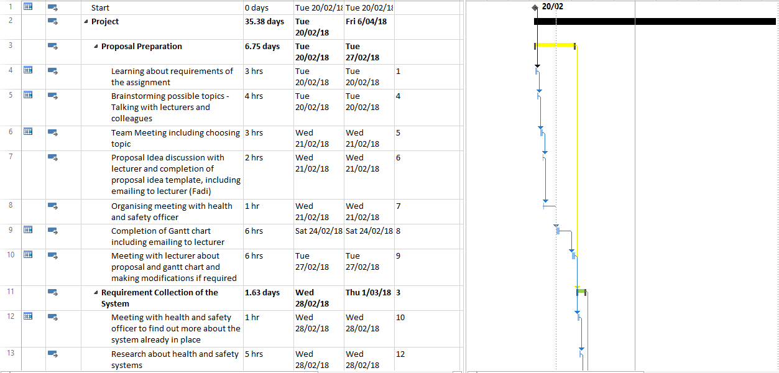

## **9.2 Appendix A.2**

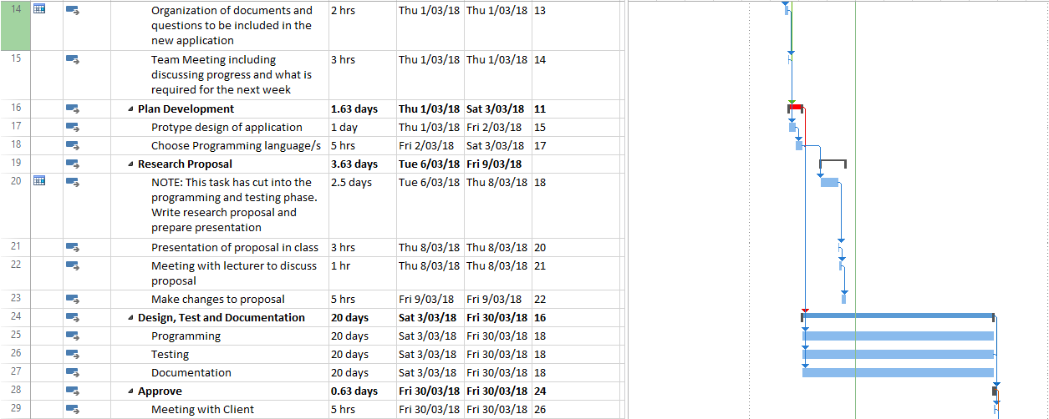

## **Appendix A.3**

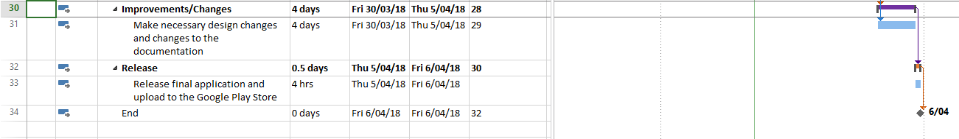

# **10. Work Breakdown Structure**

|  |  |  |  |  |
| --- | --- | --- | --- | --- |
| **Appendix** | **Task** | **Dates** | **Task Breakdown** | **Workload** |
| A.2 | 25. Programming | 3.3.18 – 30.3.18 | Using Java within the Android Studio IDE to design and code the Graphical User Interface (GUI), classes and methods which will ultimately produce the overall application. We will use the HTML programming language within Visual Studio to design and code the webpage. | Logan with Chris helping when required |
| A.2 | 26. Testing | 3.3.18 – 30.3.18 | During the programming task, there will be a lot of testing in order to get the application correct. We may encounter many errors throughout the programming phase which will need to be tested and changed to complete this task correctly. | Logan with Chris helping when required |
| A.2 | 27. Documentation | 3.3.18 – 30.3.18 | Throughout the programming and testing tasks, we will need to record how our application and website works and update our Gantt chart and proposal accordingly if any changes happen. | Chris |
| A.2 | 29. Meeting with Client | 30.3.18 – 30.3.18 | Once we have coded, tested and documented our application, website and video, we will need to sit down and discuss our progress and products with Fadi to see whether any changes need to be made or if it can be improved. | Chris and Logan |
| A.3 | 31. Make necessary design changes and changes to the documentation | 30.3.18 – 5.4.18 | Based on the previous task, we will need to make changes and improvements with the comments we receive from Fadi. Any changes made will need to be added to a team minutes meeting and recorded. | Chris and Logan |
| A.3 | 33. Release final application/website and upload application to the Google Play Store | 5.4.18 – 6.4.18 | Once we have made the final changes to our application, it will need to be uploaded to the Google Play Store to be available to students for download. The webpage will need to be uploaded and added to the [www.manukau.ac.nz](http://www.manukau.ac.nz) website so that students know where they can access the download for the application. | Chris and Logan |

# **Wireframes**

The following images are the rough sketches of what Logan and I envisioned our android application to look like. From these initial sketches, we used Microsoft Visio to produce a cleaner design that we used as a guide to design both the website and application.

If you would like to read what each activity is for, you can double click the activity to open it’s design in Microsoft Visio.

## **Home Screen Activity**

This is the home page of our application which users will see when first opening the application. Navigation to all our activities is done from this home page.

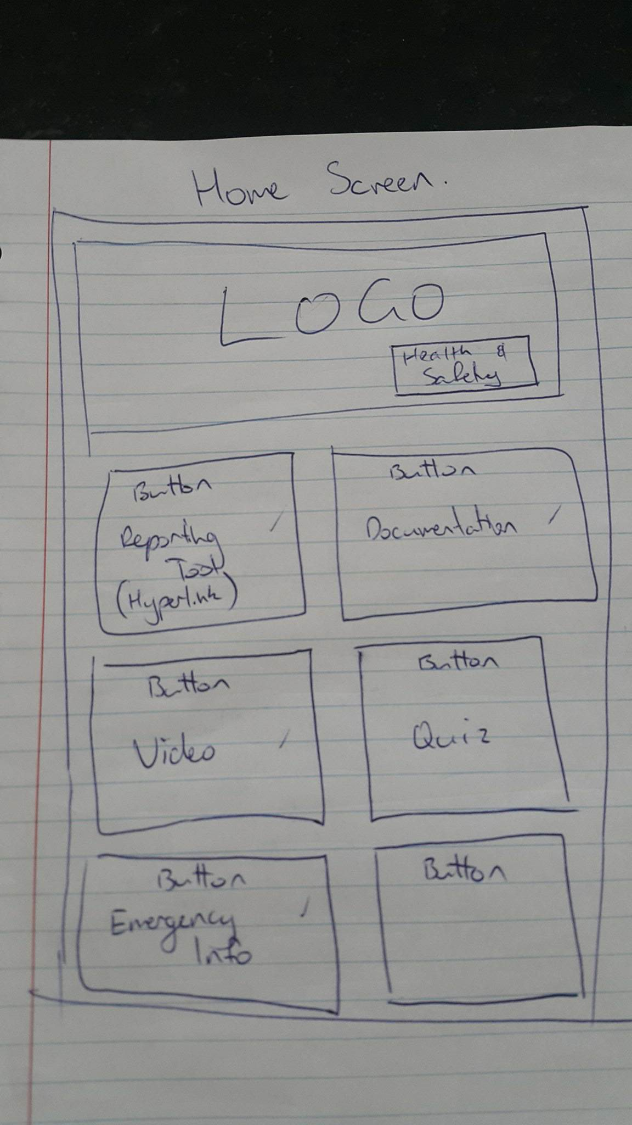

Fig. 9

## **Documentation Activity**

Note: Due to time constraints, rather than have an activity designed in android studio, we were advised by our client to change this activity to a hyperlink on the home screen activity that navigates to a website which contains health and safety information. This website is the University of Otago’s health and safety policy. Because of this, the documentation does not directly apply to our quiz so we have removed the button to be able to navigate to the quiz from this activity.

Users can however, click on the video button which will take them to the video activity and allow them to watch the health and safety video and then do the quiz.

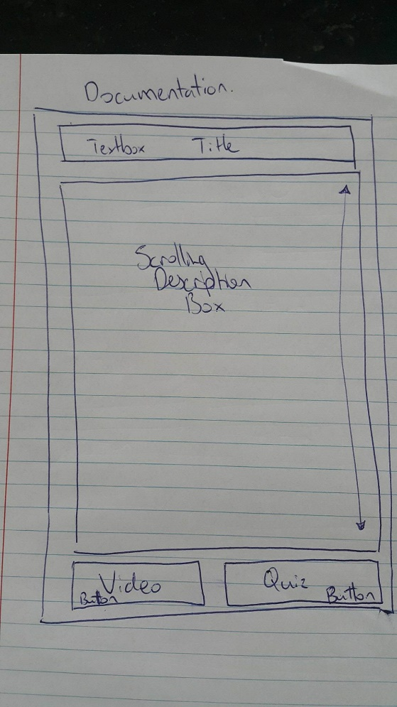

Fig.10

## **Emergency Information Activity**

This activity contains information for students for what to do in the event of an emergency.

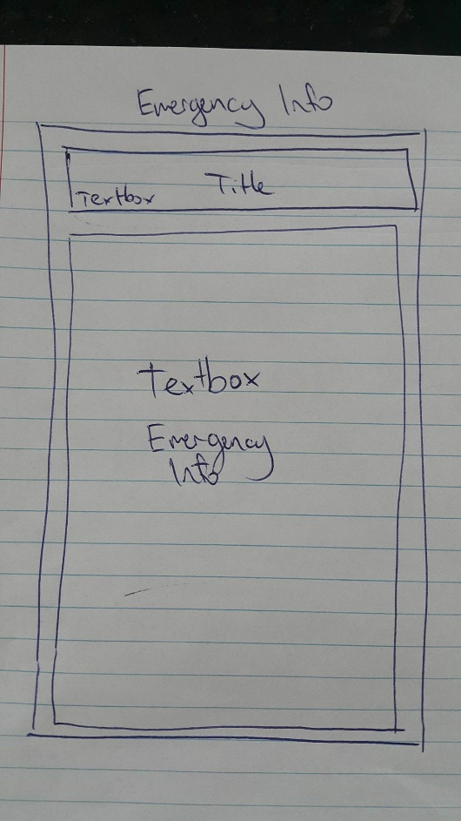

Fig. 11

## **Quiz Activity**

This activity will have ten different questions for students to answer which will relate to the video that they can preview in the application. The quiz activity will maintain the same layout for all ten questions.

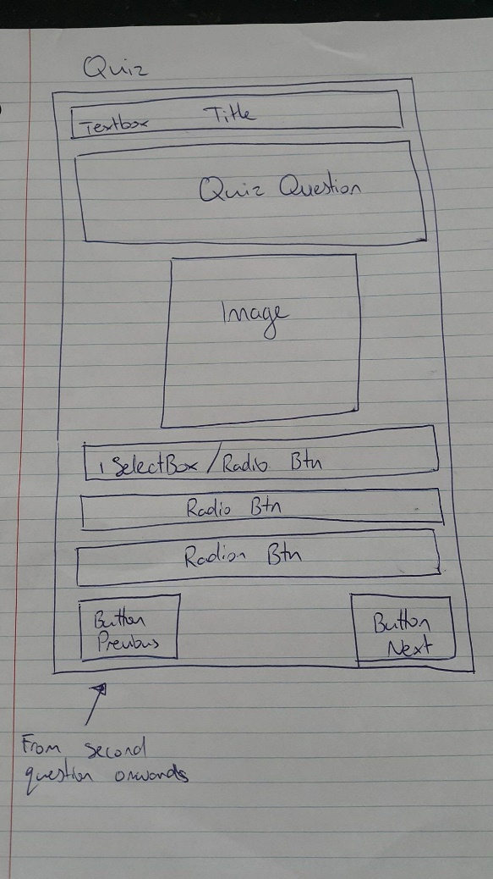

Fig. 12

## **Video Activity**

The video activity has a two and a half minute YouTube video which explains various aspects of health and safety at the Manukau Institute of Technology. Once students have viewed this video, they are able to navigate to the quiz activity to complete ten questions related to this video.

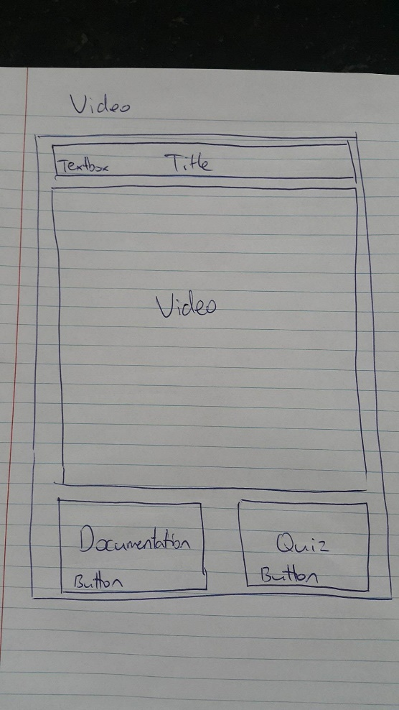

Fig.13

## **Landing Page**

This is the landing page which students can go to on the internet in order to download our android application. It features a description and image related to the application as well.



Fig. 14

# **Graphical User Interface Screens**

## **Homepage Activity**

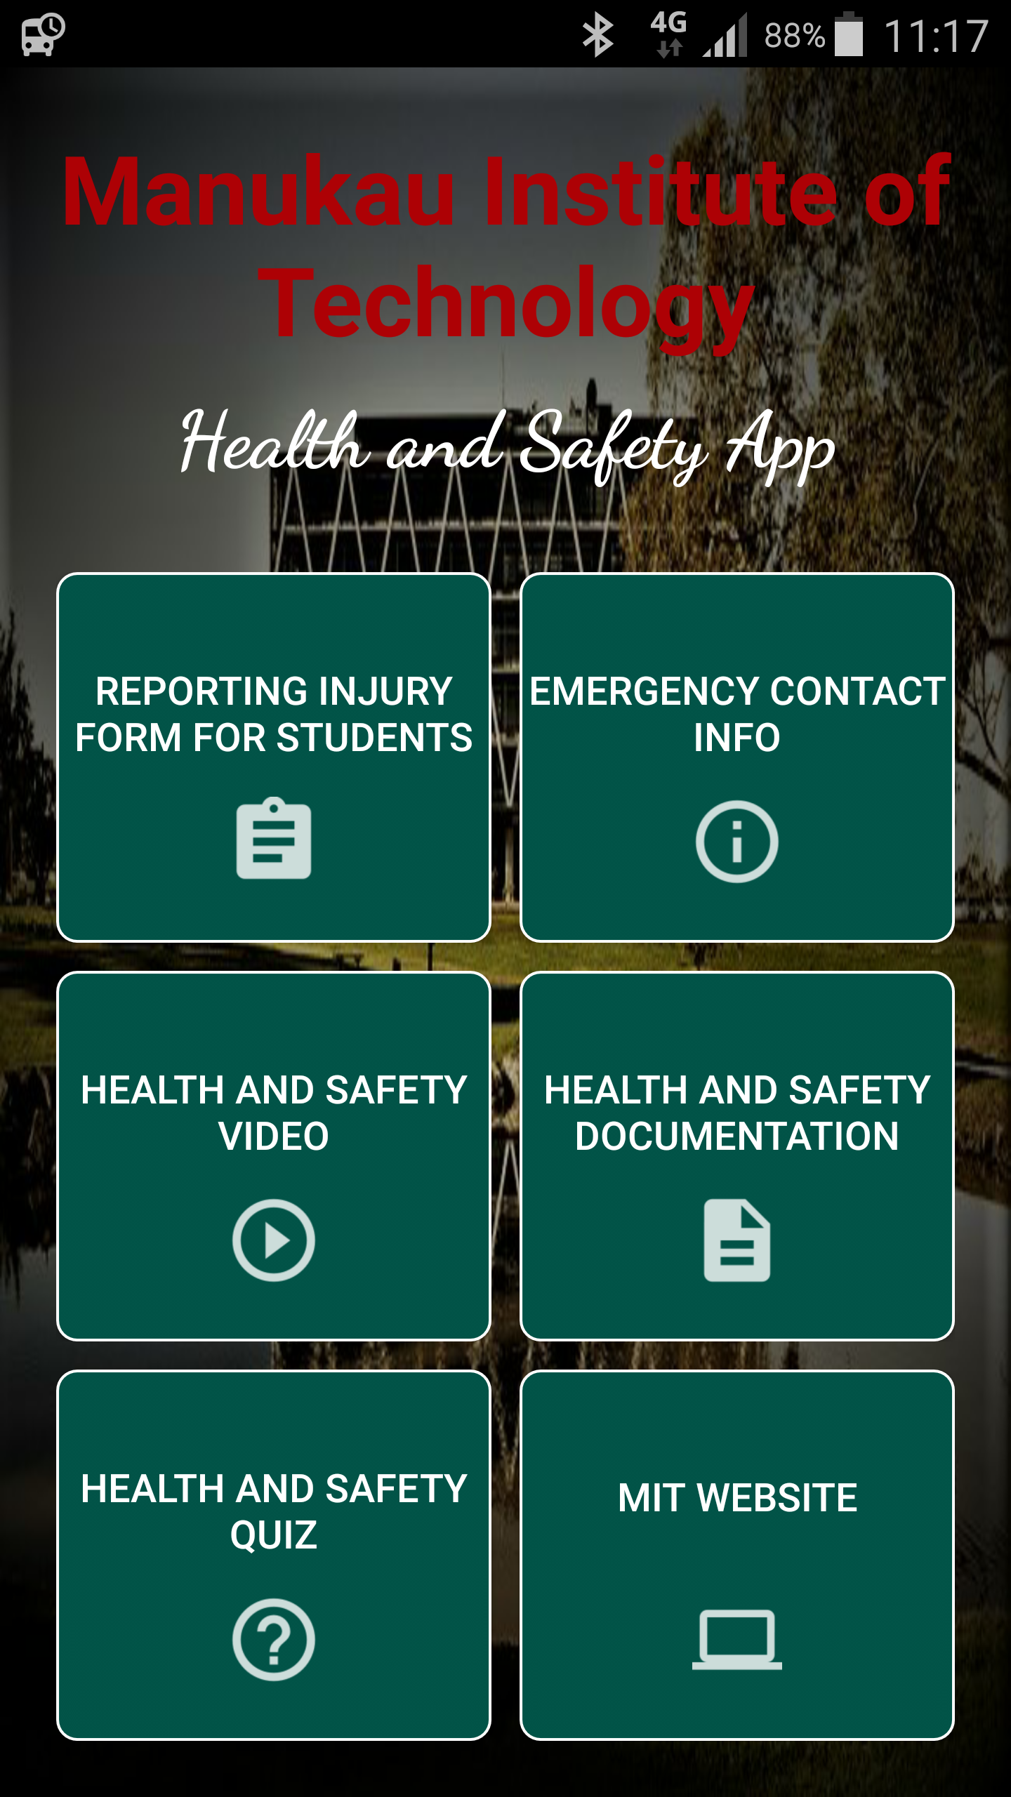

Fig. 15

## **Emergency Info Activity**

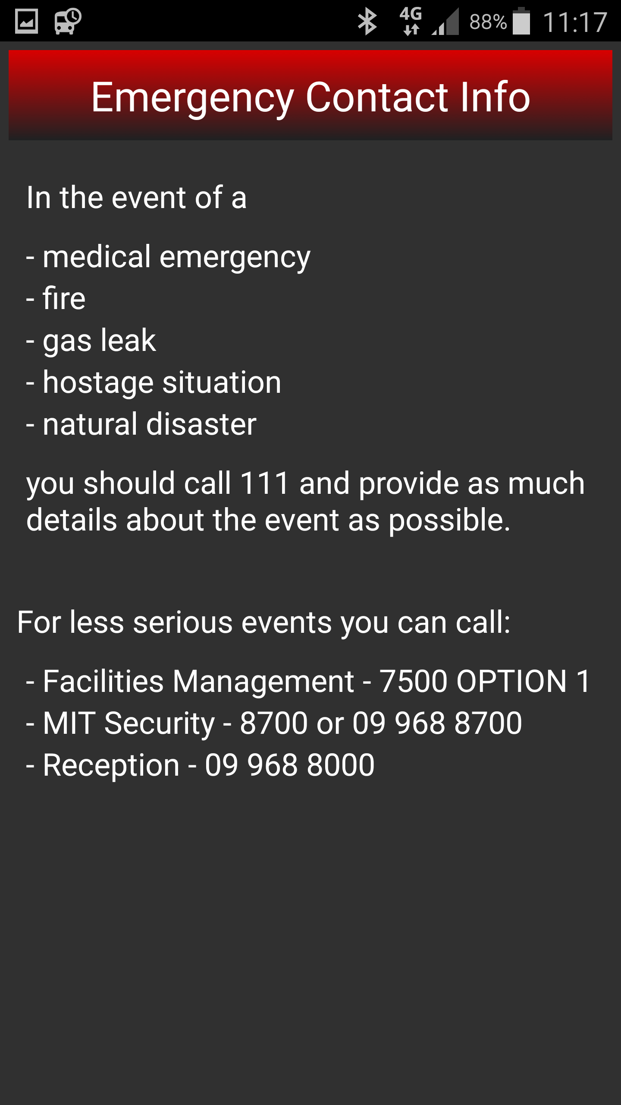

Fig. 16

## **Video Activity**

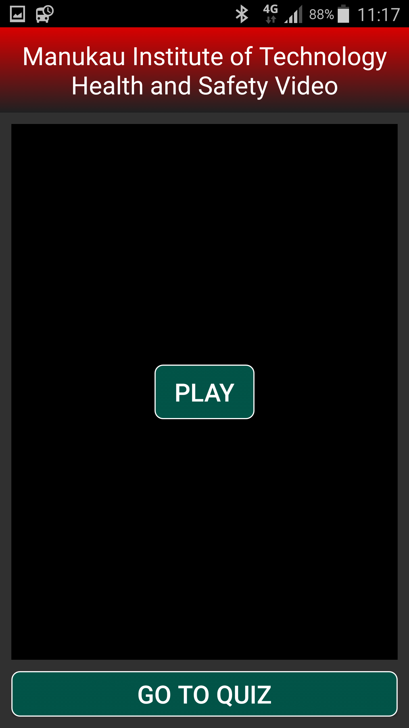

Fig. 17

## **Quiz Activity**

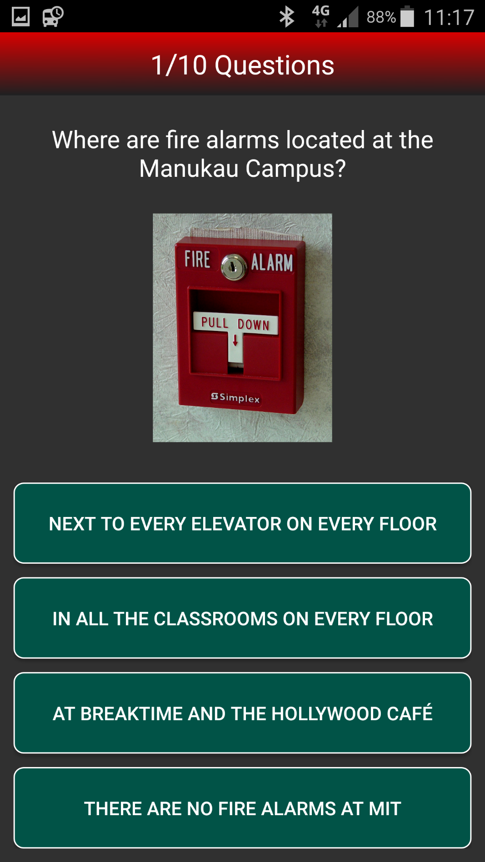

Fig. 18

## **Quiz Result Activity**

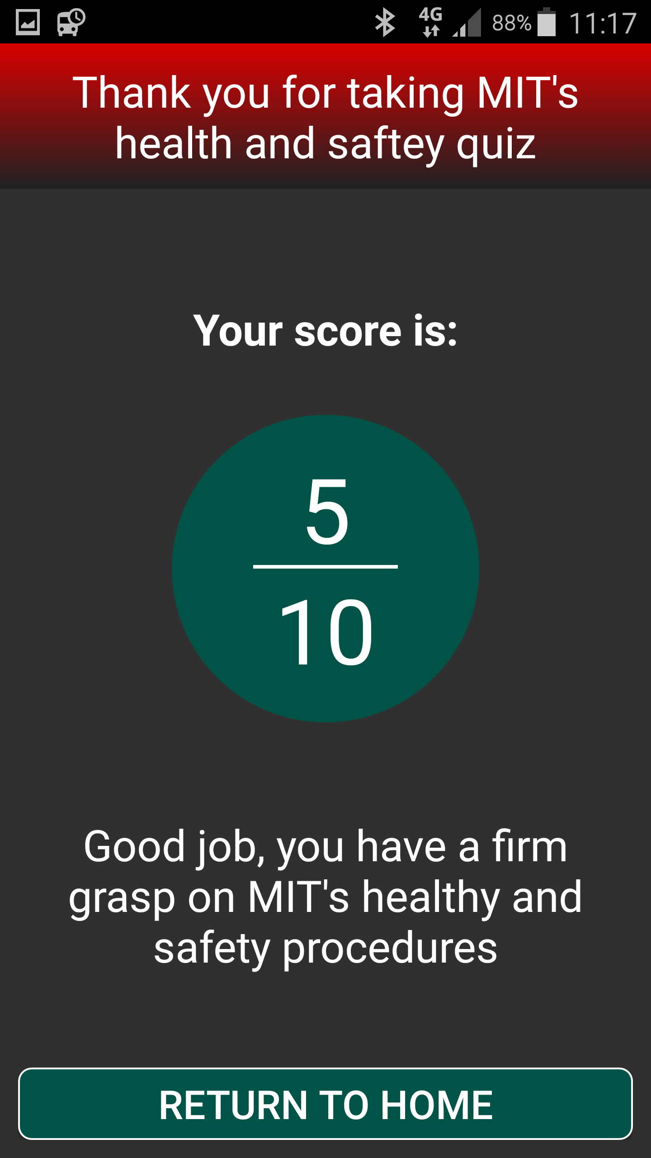

Fig. 19

# **Navigation Diagram**

This navigation diagram represents all the activities associated with our android application. When a user opens the application, the homepage activity appears which allows them to navigate to any of the other six activities that our application has. If they take the quiz, the quiz has ten sets of questions that the user can answer, and when completed, will send the results to admin staff at the Manukau Institute of Technology.

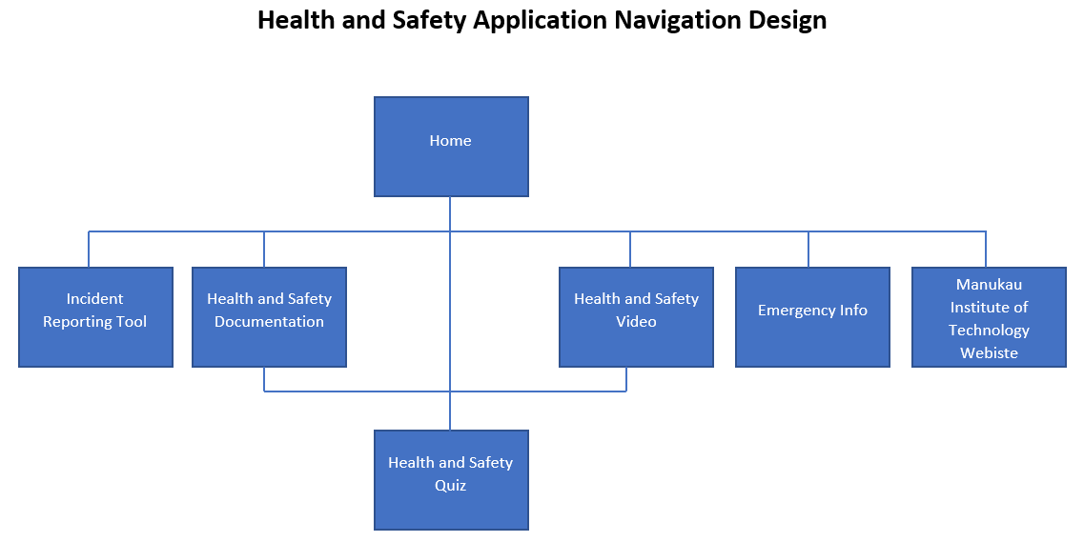

Fig. 20

# **Use Case Diagrams**

## **Administrator Landing Page Use Case**



Fig. 21

## **Administrator Android Application Use Case**



Fig. 22

## **Student Landing Page Use Case**



Fig. 23

## **Student Android Application Use Case**



Fig. 24

# **Implementation Phase**

There are many pieces of software that have been used throughout the implementation to complete all aspects of this project.

Android studio has been used to code all the activities within the application, including the applications design and functionality. This piece of software would no doubt be what Logan and I have used the most throughout the implementation phase, as the application has taken the longest amount of time during the project to develop the application. It is an extremely useful tool that makes development of applications simple and easy and it would be our first choice if we were to develop an android application again.

For the health and safety video we have created, an iPhone 6S Plus was used to shoot many small videos around the Manukau Institute of Technology’s Manukau campus. A free application on the Apple App Store called Splice was then used to link all these videos together. Once linked, the software features a cropping tool which was used to remove unnecessary parts of the video or where we had made mistakes whilst shooting. When video editing was complete, the video was uploaded to YouTube and Logan was able to reference the Internet Protocol (IP) address in the video activity to get this YouTube clip to display within our application.

Microsoft Visio was the third piece of software that we used to design our use case diagrams and navigation diagram. Copying the wireframes we sketched on paper, we were able to make these in Visio as well. Visio is a useful tool for design purposes and makes diagrams look elegant and professional.

Microsoft Word has been invaluable for the project proposal document as well. It is a powerful word processor that has very few limitations when creating a document of this magnitude. Not only that, but because Visio is a Microsoft product as well, files can be shared easily between the two applications.

Visual Studio is the last application that we have used during the implementation phase. This software was used to create the landing page for our project where users can download the application to their android phone and view details about the application as well. Once the landing page was created, we were able to a website called GitHub to publish our webpage so that anyone can see it online.

# **Error Handling**

Coding an android application is not an easy task and there are many complications Logan and I ran into along the way. There are many reasons we ran into problems, but what is more important is how we were able to solve these errors.

Some examples of the errors that we encountered:

* Calculating a total score for the health and safety questionnaire activity and pass this total score to a different activity.
* YouTube crashing in video activity when attempting to make the video full screen.
* Bringing different questions and answers for the quiz activity, into the same view.
* Using a previous and next button to navigate between questionnaire questions.

Many errors when coding, can be solved by research or discussing the error with other developers. Logan used employed the use of a search engine called Google, and a developer’s community called Stack Overflow, both of which are available on the internet. These tools were vital to find solutions to the problems we encountered.

Unfortunately, not all the errors we encountered could be solved by these two websites. Undoubtedly, there would be code that we could apply to solve all our issues, however, with our lack of knowledge at being able to apply different coding techniques and read these various fixes, we were not able to solve some of our errors in a best practice or professional way. If we had more time to complete this project, then we would have done some more problem solving, eliminated our errors, and made our application work in the way that we had originally intended. One example of this is the navigation between the health and safety questions in the quiz activity. We had intended to have a next and previous button to allow users to go back to a prior question in case they wanted to change their original answer. Sadly, we were not able to make the buttons work which means once a user picks an answer, they are navigated to the next question and cannot go back to change the answer on the previous question.

# **Improvements/Future Considerations**

Throughout our documentation and design phases, Logan and I have thought of several ways that our product is able to be improved. Unfortunately, due to time constraints, these improvements will not be able to be implemented but are ideas that we can consider for future developments.

## **Design**

Our initial design of the landing page and android application are very basic. We have focused on the functionality rather than design as the design can be improved later. Logan and I felt it was imperative we have a working application and landing page that we could show to our clients and allow them to use, then improve their aesthetics afterwards, making sure the clients are happy with their product first. If the clients wanted changes made, then the design and beauty of the product would need to be changed as well, which would have made any work we achieved on the design aspect of the product, essentially a waste of time and resource which we do not have a lot of.

## **Relevant Documentation**

Our client advised Logan and I that, to save time, we could navigate our users to existing documentation that we could find on the internet, via a hyperlink within the application. Not having to obtain the Manukau Institute of Technology’s health and safety documentation does save us a lot of time, however, documentation found on the internet does not fully relate to risks and hazards that are found at the polytechnics campuses. These risks and hazards can be identified within the video that we have created but we do feel that to improve our product, relevant Manukau Institute of Technology health and safety documentation will need to eventually be implemented into our application.

## **Databases**

The largest improvement that could be made to our product is incorporating a database. There are two aspects to this improvement. The first is to get students to sign in using their student login details when first entering the application. Once they are signed in, they are free to complete the health and safety quiz. Once they complete the quiz, the result they achieve is then saved to a database with that student’s login details, including their name and student ID. This database is important as it allows admin staff to view which students have viewed the health and safety video or documentation and completed the quiz. Any students that have not completed the quiz will then either be sent an email to remind them to complete it or a staff member can locate the student to give them a reminder to complete it if an email has already been sent to them.

The second aspect to this improvement is another database that features a wider range of health and safety questions that are incorporated and randomly selected when taking the quiz. This improvement ensures that students memory and knowledge is put to the test when taking the quiz multiple times and makes sure that even if answers are shared amongst students, the answers that are received, may not be relevant to the questions another student comes across when taking the quiz. Unfortunately, Logan and I have featured ten fixed questions that do not change as we could not get this database up and running in time for the deadline.

# **Team Meetings**

## **18.1 Meeting 1**

**Minutes of Meeting #** *1* **of** *C & L Technologies* **on** *21/02/18***at** *9.00 am till 12.00pm* **at** *MIT*

**Chairperson: Chris Watson**

**Minute Taker: Logan Shaw**

|  |  |  |
| --- | --- | --- |
| **Agenda**  **Item** | **Description *– include a heading for each item recorded and a brief summary of the discussion.*** | ***Include the following four points:*** |
| 1. | Researching and choosing a topic | Task completed by both of us. |
| 2. | Proposal ideal discussion with lecturer and completion of proposal idea template, including emailing to Fadi. | Task completed by both of us. |
| 3 | Organize meeting with health and safety officer. Chris has sent email to Fadi and Chris Mayhew. | Task completed by both of us. |
| 4 | Draft up Gantt chart for the timeline of the entire assignment. | To be completed by both of us on Saturday 24th |
| 5 | Make modification to Gantt chart and proposal template if required. | To be completed by both of us on Tuesday after seeing Fadi. |
|  |  |  |

## **18.2 Meeting 2**

**Minutes of Meeting #** *2* **of** *C & L Technologies* **on** *28/02/18***at** *12.00 am till 3.00pm* **at** *MIT*

**Chairperson: Chris Watson**

**Minute Taker: Logan Shaw**

|  |  |  |
| --- | --- | --- |
| **Agenda**  **Item** | **Description *– include a heading for each item recorded and a brief summary of the discussion.*** | ***Include the following four points:*** |
| 1. | After last weeks minute meeting, we struggled to fill in the entire Gantt chart as we did not know exactly what tasks need to be completed and by what date. Also, we were not able to get a meeting with a health and safety officer, so will see if we are able to retrieve the information we need ourselves, by having a look on the MIT website. |  |
| 2. | Find health and safety documentation on the MIT website. If cannot be found, let Fadi know to organise an interview. | To be completed by Logan |
| 3 | Complete project proposal document | Chris started this at home yesterday and we will complete the rest of the document together on Saturday and Sunday |
| 4 | Presentation | Sit down together and decide who is going to speak about what for the presentation |
| 5 | Presentation content - Using the completed project proposal, come up with notes or cue cards and things that we will speak about during the presentation that roughly equates to 5 minutes each | Complete individually over the weekend |
| 6 | PowerPoint Presentation | Each come up with our own slides with the content that we want included. Will do this together on Monday. |

## **18.3 Meeting 3**

**Minutes of Meeting #** *3* **of** *C & L Technologies* **on** *07/03/18***at** *11.00 am till 2.00pm* **at** *MIT*

**Chairperson: Chris Watson**

**Minute Taker: Logan Shaw**

|  |  |  |
| --- | --- | --- |
| **Agenda**  **Item** | **Description *– include a heading for each item recorded and a brief summary of the discussion.*** | ***Include the following four points:*** |
| 1. | Had a meeting with Fadi to discuss what we have achieved so far and what we need to do going forward. The Gantt chart was completed by Chris over the weekend which was able to be added to the PowerPoint presentation. Essentially content from the whole proposal was discussed between Logan and I and we both decided to divide this content equally by bouncing back and forth between each other for the presentation. We both added the content we were responsible for speaking about to the PowerPoint. No health and safety documentation was able to be obtained since our last meeting. |  |
| 2. | Obtain health and safety documentation from a different source to be used in our application as agreed with Fadi. | To be completed by Chris |
| 3 | Hand in Proposal and review comments if marked this week | Chris and Logan will sit down together and review any comments that Fadi has for our proposal |
| 4 | Design landing page and application navigation | Chris and Logan will complete this |
| 5 |  |  |
| 6 |  |  |

## **18.4 Meeting 4**

**Minutes of Meeting #** *4* **of** *C & L Technologies* **on** *14/03/18***at** *9.00 am till 11.00am* **at** *Logans House*

**Chairperson: Logan Shaw**

**Minute Taker: Chris Watson**

|  |  |  |
| --- | --- | --- |
| **Agenda**  **Item** | **Description *– include a heading for each item recorded and a brief summary of the discussion.*** | ***Include the following four points:*** |
| 1. | Chris was able to find health and safety documentation on the University of Wellington’s website that would be good to obtain and feature within our application. Reviewed comments made by Fadi for our proposal and will update the proposal accordingly for the final hand in. Drew some sketches together of what we would like our application to look like. Will leave the landing page design till last as the application is most important at this time. |  |
| 2. | Coding – Start researching and coding the application in visual studio | To be completed by Logan with the help of Chris if required |
| 3 | Update project proposal document with comments made by Fadi | To be completed by Chris |
| 4 |  |  |
| 5 |  |  |
| 6 |  |  |

## **18.5 Meeting 5**

**Minutes of Meeting #** *5* **of** *C & L Technologies* **on** *22/03/18***at** *11.00 am till 1.00pm* **at** *Logans House*

**Chairperson: Chris Watson**

**Minute Taker: Logan Shaw**

|  |  |  |
| --- | --- | --- |
| **Agenda**  **Item** | **Description *– include a heading for each item recorded and a brief summary of the discussion.*** | ***Include the following four points:*** |
| 1. | Logan has begun coding the home page activity of the application according to the design we sketched together. This has 6 buttons, one of which navigates to the incident reporting tool on MIT’s website via a hyperlink. Chris made changes to the project proposal which still requires more work. |  |
| 2. | Coding – Continue coding the application in android studio getting all buttons to navigate to their appropriate activities or hyperlinks | To be completed by Logan with the help of Chris if required |
| 3 | Prepare for presentation – Create the wireframes and use case diagrams that are going to be featured and discussed in our presentation, including putting these into a PowerPoint presentation | To be completed by Chris |
| 4 | Update project proposal document with diagrams that are being created in previous task | To be completed by Chris |
| 5 | Presentation – Just like in the first presentation, bounce off each other when speaking during the presentation. | Logan and Chris responsible |
| 6 |  |  |

## **18.6 Meeting 6**

**Minutes of Meeting #** *6* **of** *C & L Technologies* **on** *27/04/18***at** *11.00 am till 2.00am* **at** *Chris’s House*

**Chairperson: Logan Shaw**

**Minute Taker: Chris Watson**

|  |  |  |
| --- | --- | --- |
| **Agenda**  **Item** | **Description *– include a heading for each item recorded and a brief summary of the discussion.*** | ***Include the following four points:*** |
| 1. | Logan has made a lot of progress on the application but still has a few activities left to code. Chris updated the project proposal and discussed what more was needed with Fadi. |  |
| 2. | Coding – Continue coding the application as much as possible before Easter weekend as we will both be busy over this period. | To be completed by Logan with the help of Chris if required |
| 3 | Presentation – We have both prepared for the presentation and are ready to present tomorrow. | To be completed by Chris and Logan |
| 4 | Continue updating the project proposal with error handling and difficulties found if possible. | To be completed by Chris |
| 5 |  |  |
| 6 |  |  |

## **18.7 Meeting 7**

**Minutes of Meeting #** *7* **of** *C & L Technologies* **on** *03/04/18***at** *9.00 am till 12.00am* **at** *Chris’s House*

**Chairperson: Chris Watson**

**Minute Taker: Logan Shaw**

|  |  |  |
| --- | --- | --- |
| **Agenda**  **Item** | **Description *– include a heading for each item recorded and a brief summary of the discussion.*** | ***Include the following four points:*** |
| 1. | Logan has successfully created a functional application with 5/6 buttons navigating accordingly to either a hyperlink or the related activity. We have made a video which Chris now needs to edit, upload to YouTube and send Logan the link so he can put it in the video activity. Chris needs to give Logan the link the University of Otago’s health and safety policy so he can put it in the documentation activity of the application. Also, questions for the quiz still need to be decided upon. The presentation went well and the considerations Fadi proposed will try to be featured in the application if time permits. |  |
| 2. | Coding – Continue coding the application which will need to be finished by Monday next week as it will need to be shown to Fadi before we present to the class on Wednesday | To be completed by Logan with the help of Chris if required |
| 3 | Prepare for presentation – Decide on content needed for the final presentation, along with who is going to be talking about what. | To be completed by Chris and Logan |
| 4 | Make final changes to project proposal and get these changes checked by Fadi. Make any changes based on Fadi’s comments and submit this on Canvas | To be completed by Chris |
| 5 | Presentation – Just like in the first presentation, bounce off each other when speaking during the presentation. | Logan and Chris responsible |
| 6 |  |  |

# **Questionnaire Design**

All of the images below are released copyright through the creative commons act and legal for personal and commercial use.

Answers in YELLOW

1. Where are fire alarms located at the Manukau Campus?

* Next to every elevator on every floor
* In all the classrooms on every floor
* At Breaktime and the Hollywood Café
* There are no fire alarms at MIT

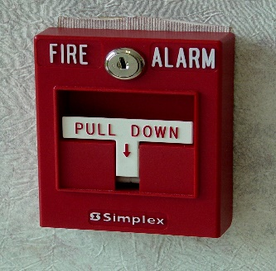

Fig. 26 (Schumin, 2004)

1. What happens when you reach the emergency assembly area during a fire?

* MIT is shut down for the rest of the day and you are free to go home
* You meet with your lecturer and classes are taken outside
* Attendance is taken to make sure everyone is okay
* Firemen give everyone instructions

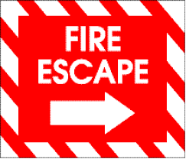

Fig. 27 (pixabay, 2014)

1. What are the ‘ABC’s of first aid?

* Accident, Body, Control
* Airways, Breathing, Circulation
* Attention, Breathing, Call-for-help
* Accidental, Breath, Calm

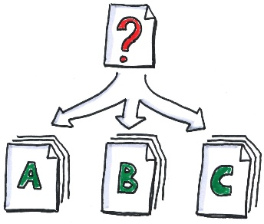

Fig. 28 (Tacke, 2013)

1. What should you do in the case of a medical emergency?

* Stay calm
* Call 111
* Apply the ABC’s of first aid
* All of the above

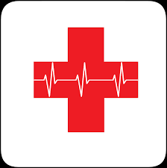

Fig. 29 (pixabay, 2015)

1. What should you do if you are inside during an earthquake?

* Run outside
* Stop, Cover and Hold
* Gather your belongings and hide under a desk
* Call 111



Fig. 30 (Iconathon, 2016)

1. What happens when the shaking from an earthquake has stopped?

* Make your way to the nearest emergency assembly area
* Make sure everyone is okay
* Call 111
* Gather your belongings and make sure they are not broken



Fig. 31 (FotoshopTofs, 2016)

1. Who is responsible for health and safety?

* The lecturers at MIT
* The health and safety representatives
* Yourself
* Everybody



Fig. 32 (geralt, 2016)

1. Where can you find more information about health and safety?

* The documentation tab of this application
* The emergency procedures guides scattered around MIT
* MIT’s website
* All of the above



Fig. 33 (geralt, pixabay, 2014)

1. What is an example of a tripping hazard at MIT?

* The power point compartments located in the floor
* The elevators at the Manukau campus
* The tiles located in the bathrooms
* All of the above

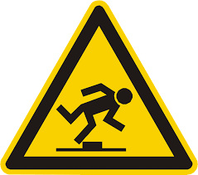

Fig. 34 (OpenIcons, 2013)

1. What should you not lean on at the Manukau campus?

* The glass panels located on every floor
* Desks and moveable whiteboards
* Any wall in the building
* The reception desk



Fig. 35 (Woodennature, 2011)

# **References**

(2014, July 30). Retrieved from pixabay: https://pixabay.com/en/sign-fire-escape-red-icon-304040/

(2015, November 16). Retrieved from pixabay: https://pixabay.com/en/first-aid-medical-aid-help-first-1040283/

dkiessling. (2016, December 1). Retrieved from pixabay: https://pixabay.com/en/web-address-website-internet-1873373/

FotoshopTofs. (2016, April 13). Retrieved from pixabay: https://pixabay.com/en/photos/stop%20sign/

geralt. (2014, December 3). Retrieved from pixabay: https://pixabay.com/en/info-information-tips-icon-support-553635/

geralt. (2016, March 27). Retrieved from pixabay: https://pixabay.com/en/road-sign-defense-defensive-1280249/

Iconathon. (2016, August 5). Retrieved from wikimedia: https://commons.wikimedia.org/wiki/File:Earthquake_House_Icons.svg

Mapbox. (2017, December 5). Retrieved from wikimedia commons: https://commons.wikimedia.org/wiki/File:Maki-emergency-phone-11.svg

MGalloway. (2014, April 4). Retrieved from wikimedia commons: https://commons.wikimedia.org/wiki/File:OOjs_UI_icon_play-ltr.svg

OpenIcons. (2013, April 1). Retrieved from pixabay: https://pixabay.com/en/trip-hazard-warning-attention-98658/

Revzin, E. (2017, December 2). Retrieved from wikimedia commons: https://commons.wikimedia.org/wiki/File:Document_icon_(the_Noun_Project_34849).svg

Schumin, B. (2004, July 6). *Simplex pull station*. Retrieved from Wikipedia: https://en.m.wikipedia.org/wiki/File:Simplex_pull_station.jpg

Tacke, O. (2013, October 13). Retrieved from flickr: https://www.flickr.com/photos/otacke/10034617715/in/photostream/

Unit, O. V. (2017, December 18). Retrieved from wikimedia commons: https://commons.wikimedia.org/wiki/File:Reporting_-_The_Noun_Project.svg

Wilke, S. (2009, January 20). Retrieved from wikimedia commons: https://commons.wikimedia.org/wiki/File:Icon-round-Question_mark.jpg

Woodennature. (2011, February 20). Retrieved from wikimedia: https://commons.wikimedia.org/wiki/File:Singapore_Road_Signs_-_Temporary_Sign_-_Caution.svg